The Rural Innovation Grant program seeks to support creative, non-traditional ideas that focus on current issues and challenges faced by rural communities associated with the themes of community investment, growth and connection. This program is a result of the Governor’s Empower Rural Iowa Initiative’s 2018 Recommendations. The program focus areas include:

Focus Area 1: Growing Rural Iowa
- Grant to support community leaders as they think holistically and act collaboratively to inform and connect leaders to rural issues; grow vibrant community gathering places; and develop tools to train and educate the next generation of leaders.
Focus Area 2: Investing in Rural Iowa
- Grant to support projects that develop creative, scalable development solutions, including but not limited to projects that address rural housing solutions; infill and reuse strategies; and affordable, sustainable designs.
Focus Area 3: Connecting Rural Iowa
- Grant to support projects that improve and expand opportunities for diverse members of Iowa’s rural communities to utilize high-speed broadband service.

The program, defined in Iowa Administrative Code, is administered by the Center for Rural Revitalization, a division of the Iowa Economic Development Authority (IEDA), in consultation with the Governor’s Empower Rural Iowa Initiative Task Forces.

Timeline
March 9, 2020 | Application Window Opens
Applications available online through IowaGrants.gov.

June 5, 2020 | Application Deadline
The deadline to submit an online application for grant funding is 11:59 p.m., Friday, June 5, 2020.

June 26, 2020 | Funding Decision Notification
Applicants will be notified of funding award decisions by June 26, 2020.

July 1, 2020 – June 30, 2021 | Funding Period
All project activities and incurred expenses must occur within the eligible contracted funding period of July 1, 2020 – June 30, 2021. Funding is awarded to grant recipients on a reimbursement basis after expenses have been incurred for approved project activities.

Funding

Grant Request Amount
Applicants may request funding for eligible one-time project expenses incurred and expended within the eligible funding period.
- Minimum Grant Request: $1,000
- Maximum Grant Request: $20,000

Match Requirement
Applicants are required to demonstrate investment in projects by providing a minimum of 1:1/2 cash match. The cash match must be secured, dedicated to eligible expenses, a legitimate part of the proposed project and must be expended within the eligible funding period. The 1:1/2 match requirement may be raised through a combination of public and private sources but may not include in-kind donations of goods or services, unsecured funding or loans. For example, an applicant that requests $10,000 in grant funds must have at least $5,000 in cash match. While the minimum match requirement is 1:1/2, competitive proposals will demonstrate broad-based financial support for the project and public funding sources adequately leveraged to seek and obtain private dollars.
- Cash match constitutes actual cash contributed to direct project expenses by the applicant or other funding sources.
- Funding from state government already being used as match from another program, including other funds from the IEDA, cannot be used to meet the match requirement.

Funding Period
All project activities and incurred expenses must occur within the eligible contracted funding period of July 1, 2020 – June 30, 2021. Funding is awarded to grant recipients on a reimbursement basis after expenses have been incurred for approved project activities within the eligible funding period. Expenses incurred before or after the eligible funding period are not eligible for reimbursement.

Disbursement of Funds
Disbursements will be made on a reimbursement basis. Disbursement claims must be for an amount equal to or greater than $500 per request. All claims must be made through Iowagrants.gov. When submitting a claim, the following items are required:

- An invoice including:
  - A detailed description of the expenditures and the corresponding amounts
  - Product invoices and proof of payment for any equipment, supplies or materials purchased
  - Receipts for any Iowa travel expenses
  - Invoices and proof of payment for any subcontractor payments
  - Timesheets for any personnel time requested
  - The IEDA may request additional documentation as needed
- A status report for the claim period. Status reports must be received once a quarter. If no funds are requested, recipients should still file a status report.

Reporting Requirements
In the application, the applicant shall provide a timeline and the goals and objectives by which to measure the success of the project. The recipients’ success will be measured based on the progress towards the completion of each goal or objective as outlined in the application.

Quarterly Reports
Each quarter, the recipient must provide an update on the percentage towards completion of each goal or objective and a narrative of the activities taken place in support of the goal or objective.

Recipients shall also provide a narrative description of any deviations from the proposed timeline, tasks and objectives during the reporting period. If the reported deviations will have an impact on the remainder of the project, the recipient must also notify the program manager via email.

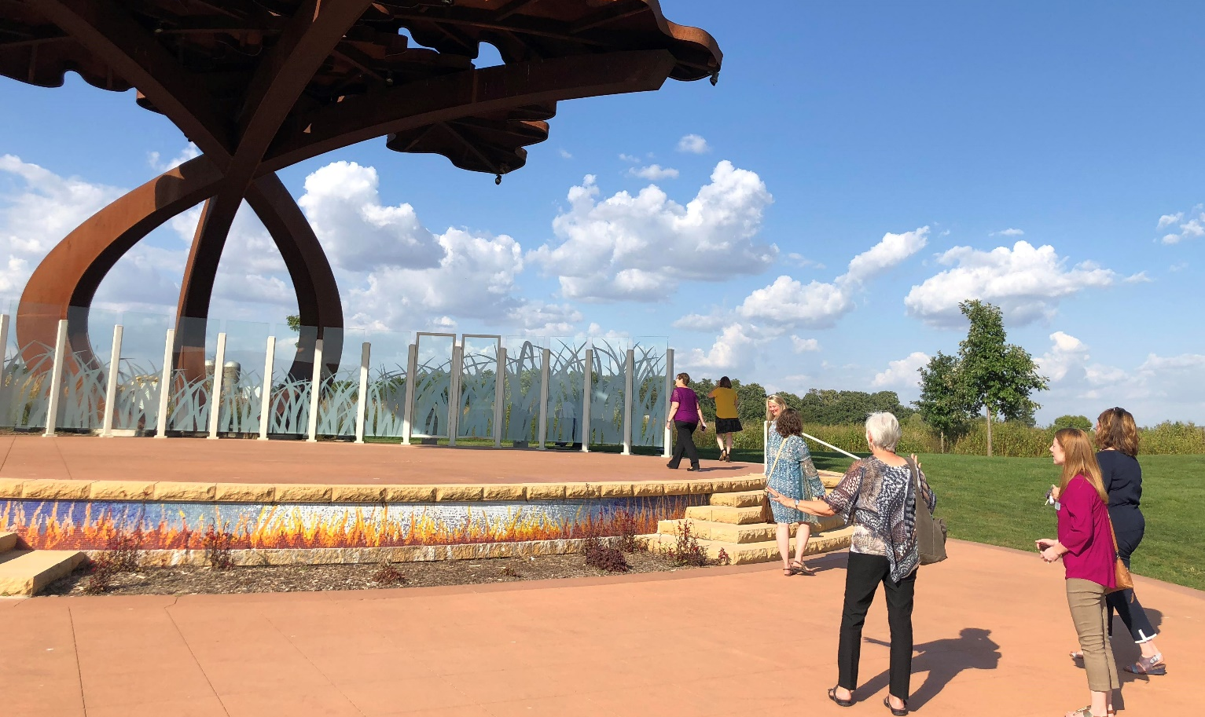
Final Report
- The final report will be submitted via IowaGrants within 120 days of the project completion date.
- The IEDA will withhold 5% of project funds until the final report is received and approved by the program manager.
- The final report shall contain the following information:
  - Executive Summary
  - Timeline of the completion of each goal or objective
  - Narrative description of grant activities undertaken to support the project
  - Narrative description of the achievements of the project
  - The benefit the end product provides or will provide
  - Budget narrative, detailing how funds were spent in support of the project
  - Narrative description of any deviation from the original budget, timeline or any grant activity

Eligibility Requirements

Eligible Applicants
Iowa businesses, colleges and universities; city or county government; and private 501(c)3 nonprofit agencies and foundations are eligible to apply. A single entity must be selected to serve as the primary applicant for grant funding applications; however, the project should include collaboration between a consortium of partners. The selected primary applicant must meet the definition of eligible applicant. The applicant will be responsible for submitting eligible material during funding application process and will be the entity legally obligated to the terms of an agreement if awarded funding. Partners and collaborating entities are not subject to the eligibility requirements but may be subject to financial and programmatic review during the selection process.

- Projects/programs must exist in and benefit a community in Iowa with a population of 20,000 or fewer and not contiguous (sharing a common border) to a city with a population of 40,000 or greater.
- Any eligible applicant may submit an application that includes one or more partners.
- Any eligible applicant will be allowed to submit one application per funding announcement. An applicant who has applied as the principal entity for an application may also be named as a partner on additional applications submitted but may not be named as a primary entity on additional applications.
- Applicant is local government entity (Mayor or City council) or applicant has included letter of support from the mayor or resolution from the city council.
- Federally tax exempt 501(c)3 nonprofit organization incorporated and physically located in Iowa.
  - Physical location of the organization is defined as maintaining a current home office and registered agent address in Iowa defined by Iowa Code 490.501, as well as maintaining a primary staff presence physically located and working in Iowa.
- Public and private schools that serve grades pre-K through 12 and are physically located in Iowa
- Nonprofit institution of higher education physically located in Iowa.
- Unit of local, county or federally recognized tribal government physically located in Iowa
- For-profit corporation or business located in Iowa.
  - A business will be considered an Iowa business if the business is incorporated in the state of Iowa or authorized to do business in the state of Iowa.

Eligible Project Requirements
Project Requirements for Rural Innovation grant awards include, but are not limited to the following:
- Applicants shall demonstrate how the project aligns to the mission of the program.
- Applicants shall demonstrate they are eligible applicants.
- Applicants shall demonstrate the capacity for grant administration.
- Applications shall demonstrate the feasibility of completing the proposed activities with the funds requested and contract period.
- Applicant is local government entity (mayor or city council) or applicant has included letter of support from the mayor or resolution from the city council.
- Applications shall identify and describe any other sources of funding for the proposed activities.
- Applications shall describe how the project will be a replicable model.
- Applications must provide a 1:1/2 cash match (grant can be up to 66% of total project cost).

Eligible Use of Funding
Eligible use of funds for Rural Innovation grant awards include, but are not limited to the following:
- Construction
- Land acquisition
- Major renovation and repair of buildings or appurtenant structures
- Park, trail or permanent design exhibits
- Site development
- Engineering, planning and design costs
- Community training program development and implementation
- Materials
- Equipment and electronics
- Marketing
- Personnel time dedicated to the project (Applicant must demonstrate how personnel time is specifically dedicated to the proposed project. Personnel benefits are not eligible.)

Eligible Project Examples
The Rural Innovation Grant program support innovative ideas that address challenges faced by rural communities associated with the themes of community investment, growth, and connection and can serve as a model for other rural communities across Iowa. The following are examples of eligible projects, please note this list is not exhaustive but reflects the variety of ways the funding can be utilized:

- Focus Area 1: Growing Rural Iowa
  - Entrepreneurship Leadership Program – Funding would be used to support the development and implementation of a leadership program within a small town focused on facilitating new business relationships for entrepreneurs, encourage cross-collaboration opportunities, and provide business training for local entrepreneurs.
  - Community Welcome Wagon – Project would utilize funds to implement a community program targeting new residents or recruiting potential residents through community activities and informational resources.
- Focus Area 2: Investing in Rural Iowa
  - Neighborhood Façade Beautification Program – This project would utilize grant funding through improving curb appeal along a downtown community street. Costs might include paint, landscaping, new fence, shutters, etc.
  - Community Clean-Up – This project would support the equipment and logistical costs for organizing a community-wide volunteer clean-up event.
- Focus Area 3: Connecting Rural Iowa
  - Main Street Wi-Fi – Funding would go towards the feasibility study and implementation of Wi-Fi within the downtown corridor of a community, ideally where there is a combination of outside seating and indoor coffee shop or restaurant as a free amenity.
  - School Bus Hotspot Project – Project would use grant funding to install the technology necessary to outfit a school bus as a hotspot for students.

Ineligible Project Activities & Expenses
Funding for existing projects or programs that do not include the significant expansion of the project or program are ineligible. The Rural Innovation Grant Program does not support ongoing expenses for existing programs or projects.

Ineligible expenses include, but are not limited to:
- International or Domestic travel (outside of Iowa)
- Insurance
- Conference or Training expenses for program providers
- Routine, reoccurring maintenance
- Ongoing utilities
- Budget shortfalls
- Fundraising or benefit event activities
- Lobbying activity
- Prizes and awards

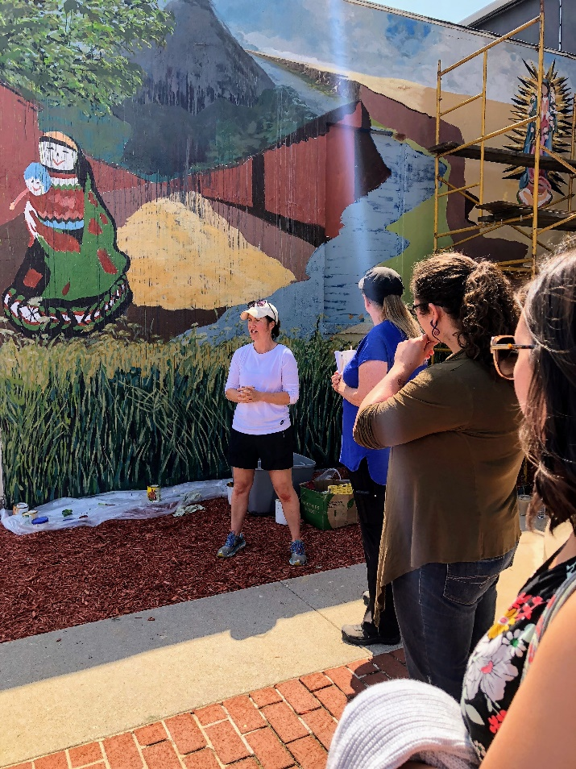
Online Application Submission
Applicants must submit applications via IowaGrants, an online application portal. Applications will not be accepted in any other format. Late, incomplete or ineligible applications will not be accepted. Applicants must create a login to view the full application for the program.

Review Process
Applications will be reviewed by staff for completion, eligibility, and adherence to published guidelines. Applications are reviewed as submitted. New application information or subsequent application clarification submitted after a program deadline is not considered. Eligible applications will be referred to a competitive review by a volunteer panel that will include Governor’s Empower Rural Iowa Initiative Task Force members and expert professionals (Grant Review Committee). The Grant Review Committee reserves the right to recommend conditional funding and partial funding of projects. Funding recommendations will be submitted by the Grant Review Committee to the director of the IEDA for consideration and approval. The applicant’s authorized official will receive award notification. All funding decisions are final.

Scoring Rubric

Eligibility Review
Applications must demonstrate evidence of the following:
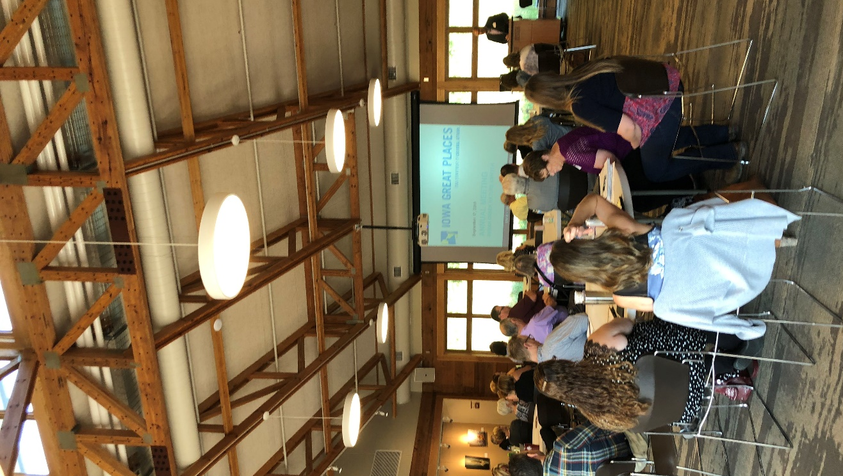
- Applicant is an eligible candidate
- Funding request meets eligible project and expense requirements
- Request is for no less than $1,000 or more than $20,000
- Request includes proof of 1:1/2 cash match for grant request
- Project duration does not exceed contract period
- Application is complete and submitted through IowaGrants.gov
- Applicant is local government entity (mayor or city council) or applicant has included letter of support from the mayor or resolution from the city council
- Primary Applicant is not named as Primary Applicant on any other applications; however, can be named as partners on additional applications

Extra consideration is provided to projects that have been endorsed by the Iowa Great Places Citizen’s Advisory Board (additional 5 points added to score total) as well as those located in a community of 5,000 or fewer (additional 5 points added to score total.)

Application Review
The Rural Innovation Grant Scoring Rubric will be used to evaluate applications. Each section has criteria and corresponding point values to ensure a fair review process. The rubric is on a scale of 55 points.

1 – MISSION ALIGNMENT: 5 points possible
5 | 3 | 1
Proposal aligns with the Empower Rural Iowa Initiative by developing a non-traditional, concrete solution to increase rural community vibrancy. | Proposal may align with the Empower Rural Iowa Initiative by developing a concrete solution to increase rural community vibrancy. | Proposal does not align with the Empower Rural Iowa Initiative by developing a solution to increase rural community vibrancy.

2 - INNOVATION: 5 points possible
5 | 3 | 1
Proposal clearly addresses rural challenges through exceptional and creative solutions. | Proposal addresses rural challenges through creative and creative solutions. | Proposal does not clearly address rural challenges through creative solutions.

3 - REPLICATION: 5 points possible
5 | 3 | 1
Detailed proposal documentation provides clear opportunity for successful replication in rural communities across Iowa. | Proposal documentation provides potential for replication in rural communities across Iowa. | Proposal documentation does not provide clear opportunity for replication in rural communities across Iowa.

4 – IMPLEMENTATION: 5 points possible
5 | 3 | 1
A viable timeline with clear milestones for measuring progress is included. | A timeline with milestones for measuring progress is included. | A vague timeline with unclear milestones for measuring progress is included.

5 - EVALUATION: 5 points possible
5 | 3 | 1
Proposal articulates clearly defined, measurable goals. | Proposal articulates defined, measurable goals. | Proposal does not articulate measurable goals.

6 – PUBLIC VALUE: 5 points possible
5 | 3 | 1
Target population for project is well-defined and its relevance to project evident. Plans to disseminate project and provide equitable access to project activities are exemplary. | Target population for the project is identified. Plans to disseminate project and provide equitable access to project activities are satisfactory. | Target population for the project is not identified. Plans to disseminate project and provide equitable access to project activities are inadequate.

7 – COMMUNITY PARTNERSHIPS: 5 points possible
5 | 3 | 1
Proposal identifies and describes in detail the roles of a variety of partners. | Proposal identifies and briefly describes the roles of a variety of partners. | Proposal does not adequately identify or describe the roles of partners.

8 - BUDGET: 5 points possible
5 | 3 | 1
Project budget and intended use of requested funds are clear and appropriate. Exceeds required 1:1/2 cash match with a variety of match sources. | Project budget and intended use of requested funds are identified and adequate. | Project budget and intended use of requested funds are unclear or inadequate.

9 – BUDGET LOCAL SUPPORT: 5 points possible
5 | 3 | 1
Majority of the applicant match is from local (including county and city government) or private sources. | Over half of the applicant match is from local (including county and city government) or private sources. | Less than half of the applicant match is from local (including county and city government) or private sources.

10 - MEDIA SUPPORT MATERIAL: 5 points possible
5 | 3 | 1
Support material is highly relevant to the projects, of high quality, and clearly supports the projects’ excellence. | Support material relates to the projects and is of average quality. | Support material is not relevant to the projects, of poor quality or does not support excellence of projects.

11 - GRANTSMANSHIP & CASE FOR SUPPORT: 3 points possible
5 | 3 | 1
The application is clear, concise and well-composed. Case for support is exemplary and merits investment from the State. | The application is clear. Case for support is adequate. | Application is unclear or poorly composed. Case for support is inadequate or does not merit State investment.

Contact
Potential applicants are encouraged to review all published material and contact Rural Community Revitalization Program Manager Liesl Seabert at 515.348.6154 or rural@iowaeda.com, with questions well in advance of application deadlines.

