The Rural Housing Assessment Grants program seeks to support the use of publicly available online information through the “Profile of Iowa” tool and rural community efforts to interpret this hard data with supplemental information, as well as to implement through changes to development codes, local ordinances and housing incentives specific to their community needs.

In partnership with Iowa State University Extension & Outreach’s Rural Housing Readiness Assessment workshops, funding from the program will empower communities to assess their current development environment and enact changes resulting in the creation of policies and procedures attractive to potential developers.

The program, defined in Iowa Administrative Code, is administered by the Center for Rural Revitalization, a division of the Iowa Economic Development Authority (IEDA), in consultation with the Governor’s Empower Rural Iowa Initiative Task Forces and the Iowa State University Extension & Outreach.
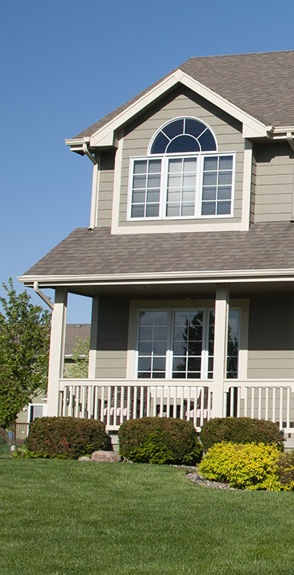

Timeline
September 1, 2020 | Application Window Opens
Applications are available online through IowaGrants.gov.

October 15, 2020 | Application Deadline
The deadline to submit an online application for grant funding is 11:59 p.m., Thursday, October 15, 2020.

November 1, 2020 | Funding Decision Notification
Applicants will be notified of funding award decisions by November 1, 2020.

November 1, 2020 – June 30, 2021 | Funding Period
All project activities and incurred expenses must occur within the eligible contracted funding period of November 1, 2020, – June 30, 2021. Funding is awarded to grant recipients on a reimbursement basis after expenses have been incurred for approved project activities.

Eligibility Requirements

Eligible Use of Funding
The Rural Housing Assessment Grant Program provides funding for housing assessment data collection and the Iowa State University Extension & Outreach Rural Housing Assessment Readiness Workshop. Funds may be used to fulfill that process at the discretion of the grant recipient but must contribute to the completion of the housing assessment report, workshop or implementation of the workshop outcomes within the contract period.

Eligible Applicants
Local city governments or federally recognized tribal governments physically located in Iowa are eligible to apply. The government must exist in and benefit a community in Iowa with a population of 20,000 or fewer and not contiguous to a city with a population of 40,000 or greater. Any eligible applicant may submit an application that includes one or more partners and may apply on behalf of an entire county assessment if the county is one of the 88 least-populous counties in Iowa.

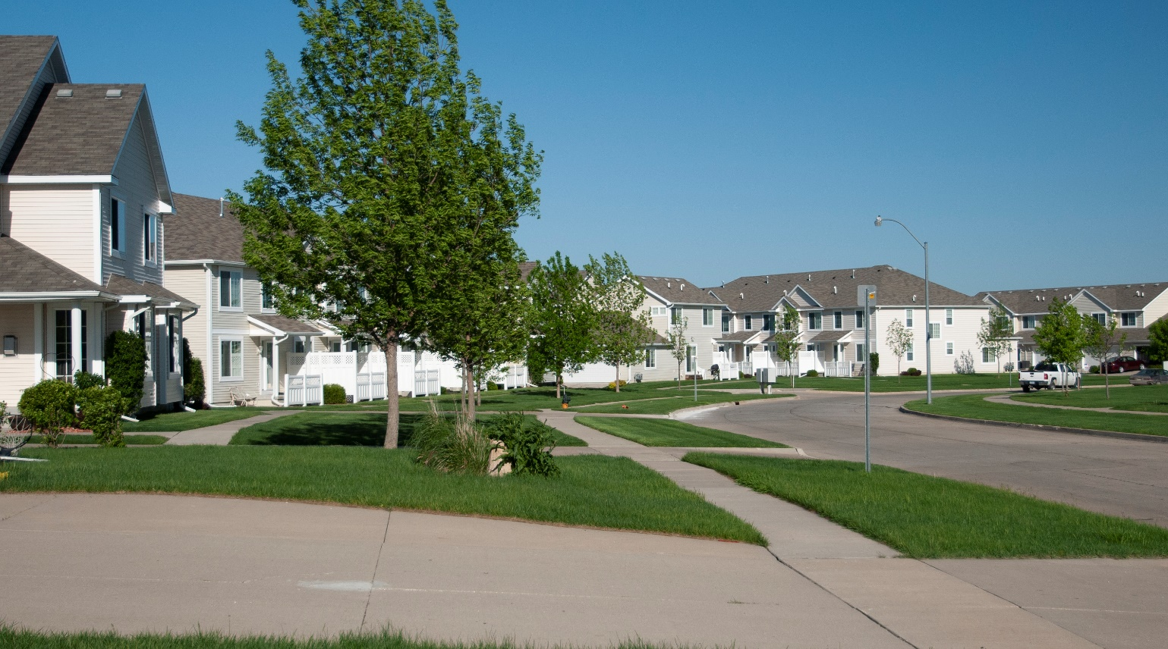
Eligible Project Requirements
Requirements for Rural Housing Assessment Interpretation and Implementation grant awards include, but are not limited to the following:
- Applicants must demonstrate the capacity for grants administration.
- Applications must demonstrate the feasibility of completing the proposed activities with the funds requested and contract period.
- Applications must identify and describe any other sources of funding for the proposed activities.
- Applications must provide $5,000 cash match.
- Applications must agree to utilize information available on the Iowa Profile tool.
- Applications must agree to contract with Iowa State University Extension & Outreach for the facilitated Rural Housing Assessment Readiness Workshop.
- Applications must identify any additional partner organizations that will be utilized in additional data collection or implementation processes.

Funding

Grant Request Amount
Grant Recipients will be awarded $10,000 to support expenses incurred within the eligible funding period. $5,000 of the total project cost must be used to contract with Iowa State University Office of Extension & Outreach for the Rural Housing Assessment Readiness Workshop.

Match Requirement
Applicants are required to demonstrate investment in the project process by providing a minimum of $5,000 cash match. The cash match must be secured, dedicated to eligible expenses, a legitimate part of the project and must be expended within the eligible funding period. The $5,000 match requirement may be raised through a combination of public and private sources but may not include in-kind donations of goods or services, unsecured funding or loans.
- Cash match constitutes actual cash contributed to direct project expenses by the applicant or other funding sources.
- Funding from state government already being used as match from another program, including other funds from the IEDA, cannot be used to meet the match requirement.

Funding Period
All project activities and incurred expenses must occur within the eligible contracted funding period of November 1, 2020, – June 30, 2021. Funding is awarded to grant recipients on a reimbursement basis after expenses have been incurred for approved project activities within the eligible funding period. Expenses incurred before or after the eligible funding period are not eligible for reimbursement.

Online Application Submission
Applicants must submit applications via IowaGrants, an online application portal. Applications will not be accepted in any other format. Late, incomplete or ineligible applications will not be accepted. Applicants must create a login to view the full application for the program.

Review Process
Applications will be reviewed by staff for completion, eligibility and adherence to published guidelines. Applications are reviewed as submitted. New application information or subsequent application clarification submitted after a program deadline is not considered. Eligible applications will be referred to a competitive review by a volunteer panel, including the Governor’s Empower Rural Iowa Initiative Task Force members, Iowa State University Extension & Outreach staff and expert professionals (Grant Review Committee). The Grant Review Committee reserves the right to recommend conditional funding and partial funding. Funding recommendations will be submitted by the Grant Review Committee to the Director of the IEDA for consideration and approval. The applicant’s authorized official will receive award notification. All funding decisions are final.

Scoring Rubric

Eligibility Review
Applications must demonstrate evidence of the following:

- Applicant is an eligible candidate
- Funding request meets eligible project and expense requirements
- Request includes proof of $5,000 cash match for grant request
- Project duration does not exceed contract period
- Application is complete and submitted through IowaGrants.gov
- Applicant local city governments or federally recognized tribal governments physically located in Iowa

Extra consideration is provided to applications that have projects supporting housing initiatives endorsed by the Iowa Great Places Citizen’s Advisory Board (additional 5 points added to score total), as well as those located in a community of 10,000 or fewer (additional 5 points added to score total.)

Application Review
The Rural Housing Assessment Grant Scoring Rubric will be used to evaluate applications. Each section has criteria and corresponding point values to ensure a fair review process. The rubric is on a scale of 57 points.

1 – APPLICANT PROFILE: 5 points possible
5 | 3 | 1
Applicant demonstrates a strong record of progress through relevant notable achievements and strategic priorities. | Applicant identified relevant notable achievements or strategic priorities. | Applicant did not adequately identify relevant notable achievements or strategic priorities.

2 – TIMING & NEED: 5 points possible
5 | 3 | 1
Proposal clearly identifies recent momentum and commitment to active participation and engagement in addressing housing needs. | Proposal identifies some recent momentum and commitment to participation and engagement in addressing housing needs. | Proposal does not clearly identify recent momentum and commitment to participation and engagement in addressing housing needs.

3 – HOUSING COMMITTEE: 5 points possible
5 | 3 | 1
Proposal clearly identifies an active housing committee with multiple, diverse partners. Key partner roles and responsibilities are well defined and will enhance the success of the process. | Proposal identifies a housing committee with multiple, diverse partners. Key partner roles and responsibilities are defined. | Proposal does not identify an active housing committee with multiple, diverse partners. Key partner roles and responsibilities are not well defined.

4 – EXISTING DOCUMENTATION: 2 points each
2 | 2 | 2
Previous Housing Studies | Downtown Upper Story Inventory | Vacant Lot Survey or Data
2 | 2 | 2
Comprehensive Plan | Current Housing-Related City Ordinances | Ordinances or Resolutions Enacting Housing-Related Incentive Programs

5 – IMPLEMENTATION: 5 points possible
5 | 3 | 1
Proposal has strong implementation objectives. Project will be successfully realized through clear, detailed timeline of deliverables. Applicant and partner responsibilities are well-defined. | Proposal has identified achievable implementation objectives and timeline of tasks. Applicant and partner responsibilities are identified. | Proposal implementation objectives are unclear or not measurable. Multiple concerns about project achievability. Timeline of tasks is insufficient. Applicant and partner responsibilities are unclear or not identified.

6 - BUDGET: 5 points possible
5 | 3 | 1
Project budget and intended use of funds are clear and appropriate. | Project budget and intended use of requested funds are identified and adequate. | Project budget and intended use of requested funds are unclear or inadequate.

7 – BUDGET LOCAL SUPPORT: 5 points possible
5 | 3 | 1
Majority of the applicant match is from local (including county and city government) or private sources. | Over half of the applicant match is from local (including county and city government) or private sources. | Less than half of the applicant match is from local (including county and city government) or private sources.

8 - SUPPORT MATERIAL: 5 points possible
5 | 3 | 1
Support material is highly relevant to the project, of high quality, and clearly supports the projects’ need. | Support material relates to the project and is of average quality. | Support material is not relevant to the project, of poor quality or does not support the projects’ need.

9 - GRANTSMANSHIP & CASE FOR SUPPORT: 3 points possible
5 | 3 | 1
The application is clear, concise and well-composed. Case for support is exemplary and merits investment from the State. | The application is clear. Case for support is adequate. | Application is unclear or poorly composed. Case for support is inadequate or does not merit State investment.

Contact
Potential applicants are encouraged to review all published material and contact Rural Community Revitalization Program Manager Liesl Seabert at 515.348.6154 or rural@iowaeda.com, with questions well in advance of application deadlines.

